IN THE COURT OF APPEAL OF LESOTHO
HELD AT MASERU
C of A (CIV) 15/2022
CCA/0142/2017
In the matter between-

PULE MOTSOPA APPELLANT
and
FIRST NATIONAL BANK OF LESOTHO 1ST RESPONDENT
DEPUTY SHERIFF: MR LEQHAOE 2ND RESPONDENT

CORAM: PT DAMASEB, AJA
MH CHINHENGO, AJA
J VAN DER WESTHUIZEN, AJA

HEARD: 19 October 2022
DELIVERED: 11 November 2022

Summary
Matter struck off the roll with costs because of the absence of a reasoned judgment of the court below, written heads of argument by the appellant and the appearance of the appellant or a legal representative of the appellant.

JUDGMENT

J VAN DER WESTHUIZEN, AJA:
[1[ In this appeal against a judgment by the High Court in favour of the first respondent the appellant purported to appeal against an order dated 23 February 2022. According to the record, no order was made in this matter on that date. This Court was not furnished with a written High Court judgment. No written heads of argument were submitted on behalf of the appellant.

[2] On the day of the hearing counsel appeared on behalf of the first respondent. In spite of attempts by the Registrar of the Court to establish whether there would be any appearance for the appellant, as well as oral indications to the Registrar that a postponement would be sought, there was no appearance on behalf of the appellant.

[3] Thus the matter had to be struck off the roll.

[4] Costs have to follow the result. Counsel for the first respondent asked for costs on the punitive scale of attorney and own client. This Court wishes to express its severe displeasure with the waste of time and resources as a result of the conduct of the appellant, his legal representatives, or both. The respondent, who duly filed heads of argument and appeared – ready to argue the appeal – should not be rendered out of pocket.
[5] The Court considered the possibility of a de bonis propriis cost order against the appellant’s counsel but decided against it in view of a lack of information as to whether the unacceptable situation was caused by the appellant, or one or more legal representatives.

ORDER
[6] The appeal is struck off the roll with costs on the scale of attorney and own client.
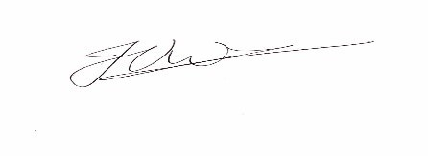
_______________________________
J VAN DER WESTHUIZEN
ACTING JUSTICE OF APPEAL
I agree:
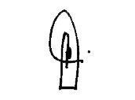
_____________________________
PT DAMASEB
ACTING JUSTICE OF APPEAL
I agree:
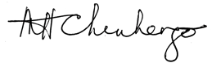
______________________
M CHINHENGO
ACTING JUSTICE OF APPEAL

FOR APPELLANT: ADV C J LEPHUTHING
For first respondent: MR K Ndebele

