IN THE APPEAL COURT OF LESOTHO
HELD AT MASERU
C of A (CIV) No.: 36/2022
In the matter between:

SELLO KHECHANE APPELLANT

AND
SEMONKONG URBAN COUNCIL 1ST RESPONDENT
ATTORNEY GENERAL 2ND RESPONDENT

CORAM : PT DAMASEB AJA
P MUSONDA AJA
J Van der WESTHUIZEN AJA

DATE OF HEARING : 13 OCTOBER 2022
ORDER DELIVERED: 11 NOVEMBER 2022

Summary
Appeal from a judgment of a subordinate court to the High Court, and a further appeal to the Court of Appeal without the necessary leave in terms of sec 17 of the Court of Appeal Act, 1978. Its provisions are peremptory and in the absence of compliance, appeal struck from the roll.

________________________________________________________________

JUDGMENT
________________________________________________________________

PT Damaseb, AJA:

Introduction

- The appellant (Mr Kechane) by originating application commenced proceedings in the district land court seeking an interdict against the first respondent to desist from unlawfully encroaching on what he alleged to be his land. The first respondent defended the claim and counterclaimed alleging that Mr Kechane had unlawfully acquired title over the land; seeking an order to void that title and to evict Mr Kechane from the disputed land.

- The district land court, based on the pleadings, documents discovered by both parties and the parties’ viva voce evidence came to the conclusion that the parties failed to prove their respective claims and ordered absolution from the instance against both. Aggrieved by that decision Mr Kechane appealed to the Land Court (court a quo) seeking an order setting aside the decision of the district land court and upholding his claim for an interdict. The court a quo dismissed his appeal and held that the district court’s conclusion was sound.

- Equally aggrieved by the decision of the court a quo, Mr Kechane lodged an appeal to this Court, claiming that the court a quo misdirected itself in its evaluation of the evidence and its approach to the onus of proof.

- The first respondent had not cross-appealed the order absolving Mr Kechane from its instance, but opposed the appeal and, apart from challenging Mr Kechane’s appeal on the merits, raised the in limine objection that the appeal was liable to be ‘dismissed’ because it was brought without leave contrary to the peremptory terms of s 17 of the Court of Appeal Act 1978, which states:
‘17. Any person aggrieved by any judgment of the High Court in its civil appellate jurisdiction may appeal to the Court with the leave of the Court or upon the certificate of the Judge who heard the appeal on any ground of appeal which involves a question of law but not on a question of fact.’

- In terms of s 74 of the Land Act 2010, the Land Court is a division of the High Court of Lesotho. Therefore, an appeal to it is caught by s 17 of the Court of Appeal Act. Ramodibedi JA wrote about the section in these terms:

‘The plain meaning of this section is that any person who intends to appeal against the judgment of the High Court in its civil appellate jurisdiction, as here, must first seek and obtain the leave of the High Court or of this Court. Furthermore, leave may be sought only on a question of law.’
. . .
[6] As guidance in future, therefore, it is now necessary to lay down the following principles:-
- Practitioners who apply for leave to appeal and judges of the court granting leave should ensure that the provisions of section 17 of the Act and the Rules of Court are strictly observed.

- The application for leave to appeal should specify the grounds on which leave is sought.

- The judge granting leave should clearly define the points of law on which leave is granted in compliance with the Rules.

- When leave is granted, the certificate of the judge and the grounds of appeal should then be delivered by the applicant.’

- In the case before us, counsel for the appellant conceded that there had not been compliance with s 17 of the Court of Appeal Act. It is common cause that Mr Kechane had not obtained leave from the court a quo nor of this Court. The appeal is therefore a nullity and cannot be entertained by this Court. The only issue is what order we should make. Dismissal is not an appropriate order when an appeal fails other than on the merits. A dismissal extinguishes the right of appeal. The proper order against and incompetent appeal is to strike it off the roll.
Order
- The appeal is struck from the roll, with costs.

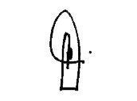
________________________________
PT DAMASEB
ACTING JUSTICE OF APPEAL

I agree:
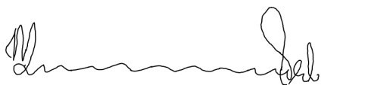
_______________________________
P MUSONDA
ACTING JUSTICE OF APPEAL

I agree:
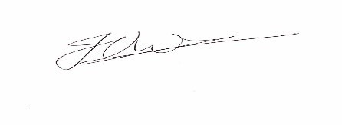
______________________________
J VAN DER WESTHUIZEN
ACTING JUSTICE OF APPEAL

For appellant: ADV KAO-THEOHA

For respondents: ADV R. SETLOJOANE

Mohale v Mohao (C OF A (CIV) No.22 of 2004) (NULL) [2005] LSHC 85 (20 April 2005) at para 4.
Mohale v Mohao (C OF A (CIV) No.22 of 2004) (NULL) [2005] LSHC 85 (20 April 2005) at para 6.

