IN THE COURT OF APPEAL OF LESOTHO

HELD AT MASERU C of A (CIV) No.10/2022
CIV/APN/68/2021

In the matter between:

MINISTER OF TRANSPORT 1ST APPLICANT
PRINCIPAL SECRETARY: MINISTRY OF TRANSPORT 2ND APPLICANT
MOHLALEFI LETSAPO 3RD APPLICANT
PALESA MAILE 4TH APPLICANT
LISEMA RASENYA 5TH APPLICANT
ATTORNEY GENERAL 6TH APPLICANT

AND

KATLEHO LOGISTICS (PTY) LTD RESPONDENT

COURT ORDER

CORAM: K E MOSITO, P
N T MTSHIYA, AJA
J VAN DER WESTHUIZEN, AJA

HEARD: 20 APRIL 2022
DELIVERED: 13 MAY 2022

BY ORDER OF COURT

The Deed of Settlement signed by the Parties’ legal representatives on the 20TH APRIL 2022 be and is hereby made an Order of Court in the following terms:-

- The RESPONDENT abandons the impugned order granted by HIS LORDSHIP MR. JUSTICE MONAPATHI granted on the 9th day of NOVEMBER 2021 in terms of RULE 44 of THE HIGH CURT RULES LEGAL NOTICE NO.9 OF 1980 (As amended) on the terms as shall be spelt out in this agreement.

- The parties further agree that each party to the proceedings referred to above is to pay its own legal costs.

- That PRAYERS 1 and 2 be granted by consent of the parties and further that:

- The matter is referred back to the HIGH COURT for determination of the main application.

- MINISTER OF TRANSPORT and PRINCIPAL SECRETARY OF MINISTRY OF TRANSPORT and or their authorized agents in the MINISTRY OF TRANSPORT are prohibited and or interdicted from interfering with the continued commercial activities of KATLEHO LOGISTICS PTY. LTD. Pending finalization of issues per CLAUSE 3(a) above.

- MINISTER OF TRANSPORT and PRINCIPAL SECRETARY OF MINISTRY OF TRANSPORT are prohibited from engaging an alternative administrator in preference over KATLEHO LOGISTICS pending finalization of the issues referred to in CLAUSE 3 (a) above.

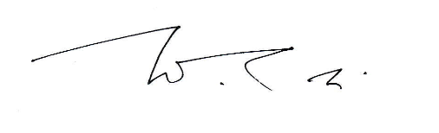
_______________________________
N T MTSHIYA
ACTING JUSTICE OF APPEAL

________________________________
K E MOSITO
PRESIDENT OF THE COURT OF APPEAL

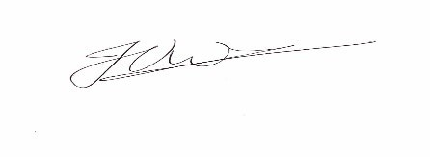
_______________________________
J. VAN DER WESTHUIZEN
ACTING JUSTICE OF APPEAL

FOR APPLICANTS: ADV L TAU
FOR RESPONDENT: ADV M S RASEKOAI

